HEALTH PILOT: AGENTIC AI HEALTH & WELLNESS COACH

HealthPilot: A LangGraph-Orchestrated Multi-Agent Platform for Personalised

Health and Wellness Coaching, Safety Validation and Adaptive Recommendations

AD23731 Foundations of Agentic AI - Mini-Project
Submitted by
Sarveesh B - 231501148
Rubarajan - 231501138
Trishanth D.P.J - 231501175

Department of Artificial Intelligence and Machine Learning

DEPARTMENT OF
ARTIFICIAL INTELLIGENCE AND MACHINE LEARNING RAJALAKSHMI ENGINEERING COLLEGE
THANDALAM, CHENNAI, 602105



BONAFIDE CERTIFICATE

Certified that this mini-project report “HEALTH PILOT: AGENTIC AI HEALTH &
WELLNESS COACH” is the bonafide work of “Sarveesh B (231501148),
Rubarajan(231501138), Trishanth D.P.J (231501175)” VII Semester, B.Tech. Artificial Intelligence and Machine Learning Department, in partial fulfilment of the requirements of the course AD23731 – Foundations of Agentic AI during the Academic Year 2026 – 2027.

Faculty in-charge

Submitted to mini-project viva voce examination held on: ………………………

INTERNAL EXAMINER EXTERNAL EXAMINER

Table of Contents
1. INTRODUCTION 5
1.1 Background and Motivation 5
1.2 Need for Agentic AI 6
1.3 Project Objectives 8
2. PROBLEM STATEMENT AND BUSINESS CASE 10
2.1 Problem Definition…………………………………………...10
2.2 Business and Real-World Context 10
3. USER AND STAKEHOLDER ANALYSIS 11
3.1 Target Users 13
3.2 Stakeholder Identification 13
3.3 User Requirements 14
4. PROPOSED AGENTIC AI SOLUTION 16
4.1 Overall Solution 16
4.2 Key Features 16
4.3 Agent-Based Approach 17
5. DATASET / KNOWLEDGE SOURCES 19
5.1 AeroGround Retrieval Corpus 19
5.2 AMT Airframe Handbook Dataset 19
5.3 AeroGround Abstention Dataset 20
5.4 Knowledge-Source Limitation 20
6. TOOLS AND TECHNOLOGIES USED 22
7. AGENT ARCHITECTURE 23
7.1 Agent Components 23
7.2 Tools 24
7.3 Memory and State 24
7.4 Reasoning Flow 25
7.5 Agent Interactions 25
8. AGENT WORKFLOW AND ORCHESTRATION 27
8.1 Workflow Design 27
8.2 Task Decomposition 27
8.3 Agent Coordination 28
8.4 Orchestration Implementation 29
9. AGENTIC RAG IMPLEMENTATION 30
9.1 Retrieval Architecture 30
9.2 Knowledge Retrieval 30
9.3 Generation Process 31
9.4 Citation Validation 31
9.5 Retrieval-Quality Evaluation 32
10. SYSTEM IMPLEMENTATION 33
10.1 Functional Prototype 33
10.2 RAG Output 34
10.3 Human Review Interface 35
10.4 Auditability 38
10.5 Source-Code Repository 38
10.6 Screenshots 38
11. EXPERIMENTAL EVALUATION AND RESULTS 39
11.1 Evaluation Metrics 39
11.2 Testing Methodology 40
11.3 Functional Test Cases 40
11.4 Performance Results 42
11.5 Success-Metric Achievement 42
12. COMPARISON, INNOVATION AND SCALABILITY 43
12.1 Comparison with Baseline 43
12.2 Advantages of the Proposed System 43
12.3 Innovation 44
12.4 Scalability 44
12.5 Real-World Applicability 44
13. CONCLUSION AND FUTURE WORK 45
13.1 Conclusion 45
13.2 Future Work 46
7

“HEALTH PILOT: AGENTIC AI HEALTH & WELLNESS COACH”

1. INTRODUCTION

1.1 Background and Motivation
Health and wellness management involves continuously monitoring and addressing multiple interconnected factors such as physical activity, sleep, nutrition, mental well-being and daily habits. These factors influence one another, making personalised health management a complex and continuous decision-making problem. Users may have different goals, lifestyles, behavioural patterns and wellness requirements, and therefore a single fixed recommendation or static application may not be sufficient to provide effective personalised guidance. In addition, health-related recommendations must consider safety, conflicting requirements and the limitations of automated decision-making.
Traditional health and wellness applications generally rely on predefined rules, static questionnaires, individual recommendation modules or simple conversational interfaces. Although these approaches can provide useful information, they often lack the ability to coordinate multiple specialised tasks, maintain meaningful user context and continuously adapt recommendations based on changing user behaviour. A conventional chatbot can answer questions, but it may not reliably execute a sequence of reasoning, retrieval, validation and decision-making operations required for personalised wellness management. An integrated intelligent framework is therefore required to combine multiple specialised capabilities while maintaining safety, consistency and user-specific context.
The HealthPilot – Agentic AI Health and Wellness Coach is a research-oriented intelligent wellness platform designed to address this problem. It uses an agentic artificial intelligence architecture in which multiple specialised agents collaborate to analyse user requirements and generate personalised recommendations. A Supervisor Agent initially interprets incoming requests and routes them to appropriate specialist agents such as the Sleep Agent, Fitness Agent, Nutrition Agent and Mind Agent. These agents independently analyse their respective domains, while a Mediator component helps resolve conflicts when recommendations from different specialists interact with one another.
The platform is designed not simply as a conversational health assistant but as an integrated multi-agent decision-support framework. It combines agentic workflows, Retrieval-Augmented Generation (RAG), memory, natural language processing, recommendation validation and safety mechanisms to provide context-aware wellness guidance. The system incorporates a Safety Guardian that independently evaluates recommendations for potentially unsafe outcomes, while a Cross-Model Critic provides an

additional validation layer. Human-in-the-loop approval can also be incorporated for decisions that require additional verification or user confirmation.
HealthPilot further incorporates an agentic RAG pipeline to improve the reliability and contextual relevance of generated responses. Instead of directly generating an answer from a language model, the system can analyse the user's query, plan the required retrieval operations, retrieve relevant information, evaluate the quality of the retrieved results and retry the retrieval process when the available evidence is insufficient. The platform also maintains short-term and long-term user context, allowing recommendations to be adapted according to previous interactions, preferences, habits and behavioural patterns.
The system extends beyond one-time recommendations by supporting continuous wellness analysis. User information can be processed using NLP-based mood, intent and habit analysis, while nutrition, fitness, sleep and mental-wellness information can be combined to generate personalised recommendations. The platform can perform periodic reviews of user progress and adapt recommendations based on observed behavioural changes. This enables the system to move from a reactive question-answering model towards a more proactive and personalised wellness-coaching framework.
The project therefore addresses two interconnected challenges:
- How can multiple specialised AI agents, memory, RAG, safety validation and human oversight be integrated into a unified architecture capable of providing personalised and reliable health and wellness recommendations?
- How can the system continuously analyse user context, behavioural patterns and wellness information to adapt recommendations across nutrition, fitness, sleep and mental well-being while maintaining safety and consistency?

The combination of multi-agent artificial intelligence, LangGraph-based workflow orchestration, Retrieval-Augmented Generation, natural language processing, memory, recommendation validation and safety mechanisms forms the central motivation behind the HealthPilot project.

1.2 Need for Intelligent and Agentic AI
Conventional health and wellness applications rely heavily on predefined rules, static questionnaires, isolated recommendation modules and single-model conversational systems. Although large language models can provide useful responses to health-related queries, a single model cannot reliably manage the complex interactions between nutrition, fitness, sleep and mental well-being while simultaneously maintaining user context, validating recommendations and handling safety requirements. Wellness management involves multiple interconnected tasks, making it more suitable to divide the overall problem into specialised intelligent components.
In this system, the major tasks are divided as follows:
- Supervisor Component analyses the incoming user request, identifies its intent and determines which specialised workflow or combination of agents is required to address the request.
- Nutrition Agent analyses dietary requirements, user preferences and nutritional goals to generate personalised food and nutrition recommendations. It can also incorporate retrieved information and validate recommendations before presenting them to the user.
- Fitness Agent focuses on physical activity and exercise-related requirements. It analyses the user's goals and context to generate suitable fitness recommendations while considering interactions with other wellness factors.
- Sleep Agent analyses sleep-related concerns, patterns and user requirements to provide personalised guidance for improving sleep quality and maintaining healthy sleep habits.
- Mind Agent focuses on mental wellness and behavioural context. It can analyse user messages for relevant mood, intent and habit-related information and provide appropriate wellness-oriented recommendations.
- Mediator Component coordinates recommendations generated by multiple specialist agents and resolves conflicts when recommendations from different domains affect one another. This allows the system to produce a unified response rather than presenting disconnected suggestions from individual agents.
- Agentic RAG Component retrieves relevant information required for generating reliable responses. It performs query planning, retrieval and evaluation of retrieved information, and can retry the retrieval process when the available information is insufficient or unsuitable.
- Memory Component maintains relevant short-term and long-term user context so that recommendations can be personalised according to previous interactions, preferences, habits and progress rather than treating every interaction as an isolated request.
- Safety Guardian Component independently evaluates generated recommendations for potential safety issues before they are delivered to the user. This provides an additional layer of protection beyond the reasoning performed by the individual specialist agents.
- Cross-Model Critic Component provides an independent evaluation of generated outputs by reviewing recommendations for quality, consistency and potential issues.
This additional validation layer reduces dependence on a single model's reasoning.
- Human-in-the-Loop Component provides an additional approval mechanism for situations where automated recommendations require human verification or user confirmation before execution.
- Continuous Review and Adaptation Component analyses accumulated user information and behavioural patterns to perform periodic wellness reviews. The system can use these observations to adapt future recommendations according to changes in the user's habits, goals and progress.
These components do not operate as isolated AI modules. They are connected through an orchestrated multi-agent workflow, allowing information and decisions to move between the Supervisor, specialist agents, Me

1.3 Project Objectives
The major objectives of the project are:
- To develop an agentic AI health and wellness coaching system using a supervisor-routed, multi-agent LangGraph workflow.
- To analyse user requests and automatically route them to specialised wellness agents such as Nutrition, Fitness, Sleep and Mind agents.
- To generate personalised recommendations based on the user's wellness goals, preferences, behavioural patterns and accumulated context.
- To implement an Agentic Retrieval-Augmented Generation (RAG) pipeline capable of planning queries, retrieving relevant information, evaluating retrieval quality and retrying when necessary.
- To maintain short-term and long-term user memory so that the system can provide context-aware and continuously personalised wellness recommendations.
- To coordinate recommendations from multiple specialist agents through a Mediator component and resolve conflicts between different wellness domains.
- To implement a Safety Guardian that independently evaluates generated recommendations and identifies potentially unsafe or inappropriate outputs before they reach the user.
- To incorporate a Cross-Model Critic for independent evaluation of AI-generated recommendations, improving reliability, consistency and output quality.
- To provide a human-in-the-loop mechanism for cases where automated recommendations require additional verification or user approval.
- To analyse user messages and behavioural information using NLP-based mood, intent and habit analysis to support personalised wellness decisions.
- To perform continuous or periodic wellness reviews and adapt recommendations based on changes in user behaviour, habits, goals and progress.
- To provide an integrated and extensible architecture combining multi-agent orchestration, RAG, memory, NLP, safety validation and personalised recommendation generation within a unified wellness platform.

2. PROBLEM STATEMENT AND BUSINESS CASE

2.1 Problem Definition
Individuals often face difficulty in maintaining a consistent, personalised and safe approach to managing their overall health and wellness. Effective wellness management must simultaneously consider multiple interconnected factors, including:
- accurate understanding of the user's health and wellness requirements,
- personalised nutrition and dietary recommendations,
- appropriate fitness and physical-activity guidance,
- effective sleep-related recommendations,
- consideration of mental well-being and behavioural patterns,
- consistent recommendations when multiple wellness domains interact,
- reliable information retrieval for knowledge-based queries,
- protection against potentially unsafe or inappropriate recommendations, and
- continuous adaptation based on user behaviour, preferences and previous interactions.
Existing approaches usually treat these wellness requirements as separate activities or provide them through static rule-based applications. Where AI is used, it is often implemented as a standalone chatbot that may generate unsupported information, provide inconsistent recommendations, fail to maintain meaningful user context or overlook safety considerations. A single language model may also struggle to coordinate multiple specialised wellness tasks and resolve conflicts between recommendations from different domains.
The problem addressed by this project can therefore be stated as:

Develop an intelligent end-to-end health and wellness coaching system using coordinated AI agents while keeping safety-critical validation independent, wellness information grounded through Retrieval-Augmented Generation, personalised recommendations supported by persistent user context, and conflicting decisions coordinated through specialised agents and a mediation layer.

2.2 Real-World Context
Individuals managing their health and wellness often deal with information scattered across different applications, routines and sources. A person may track their diet separately from exercise, monitor sleep through another application and seek mental-wellness guidance through a conversational assistant. This fragmented approach makes it difficult to understand how different aspects of wellness influence one another. Users need a unified system that can analyse their requirements, provide personalised recommendations and continuously adapt to their changing behaviour.
Different users may also have different wellness requirements and expectations:
- A general user should receive personalised recommendations based on their goals, preferences, habits and previous interactions.
- A fitness-focused user may require exercise and physical-activity recommendations while also considering factors such as sleep, nutrition and recovery.
- A nutrition-focused user may require personalised dietary guidance based on their goals, preferences and behavioural context.
- A user seeking mental-wellness support may require appropriate guidance based on mood, intent and behavioural patterns, while maintaining safety boundaries.
Consequently, a single generic chatbot or a static rule-based wellness application cannot effectively satisfy all these requirements. HealthPilot therefore treats personalisation, multi-domain coordination, information reliability, safety and continuous adaptation as simultaneous requirements. The system uses specialised AI agents coordinated through an agentic workflow so that different aspects of wellness can be analysed independently while still contributing to a unified and context-aware recommendation.

2.3 Business Case
The HealthPilot – Agentic AI Health and Wellness Coach can be considered an intelligent wellness-management platform with potential applications in:
- Individual health and wellness management
- Fitness and nutrition coaching platforms
- Corporate employee wellness programmes
- Educational institutions supporting student wellness
- Gyms, fitness centres and personal coaching services
- Digital health and wellness technology providers
Potential future business models include:
- Software-as-a-Service (SaaS) subscriptions based on individual users or organisations
- Integration with wearable devices and health-tracking platforms to incorporate activity, sleep and other wellness data
- Integration with existing fitness, nutrition and wellness applications
- Premium personalised coaching and advanced wellness analytics
- Organisation-level wellness dashboards for monitoring aggregated, privacy-preserving engagement and progress
- Custom deployment with organisation-specific wellness knowledge bases and recommendation policies
- Premium access to advanced multi-agent coaching, continuous reviews and personalised wellness plans
The current project focuses on developing and demonstrating the technical feasibility of an agentic AI-based wellness coaching platform rather than implementing a commercial business model. The primary objective is to demonstrate how specialised AI agents, RAG, memory, safety validation and continuous adaptation can be integrated into a unified and extensible health and wellness system.

3. USER AND STAKEHOLDER ANALYSIS

3.1 Target Users
The system targets individuals and organisations that want personalised health and wellness support while maintaining safety, context and control over AI-generated recommendations. The platform is designed to support users with different wellness goals across nutrition, fitness, sleep and mental well-being.
The primary users include:
- General users seeking personalised wellness guidance.
- Fitness-focused users seeking exercise and activity recommendations.
- Users requiring personalised nutrition and dietary guidance.
- Users seeking mental-wellness and behavioural support.
- Organisations interested in AI-assisted employee wellness programmes.
Primary Users
General Wellness Users. Receive personalised recommendations for nutrition, fitness, sleep and mental well-being based on their goals, preferences and previous interactions.
Fitness and Nutrition Users. Access specialised exercise, activity and dietary recommendations tailored to their individual requirements.
Mental Wellness Users. Receive appropriate wellness guidance based on mood, intent and behavioural patterns.
Secondary Users
Corporate Wellness Programmes. Benefit from personalised AI-assisted wellness support and continuous health and lifestyle guidance for their users.

3.2 Stakeholders
The major stakeholders include:
Stakeholder | Role
Wellness Users | Provide wellness goals, preferences and interactions to receive personalised recommendations
Nutrition / Fitness Users | Use specialised nutrition, exercise and activity recommendations
Mental Wellness Users | Receive personalised guidance based on mood, intent and behavioural patterns
Project Team | Designs, develops and maintains the system
LLM / AI Provider | Provides language understanding, reasoning, classification and response generation
Knowledge Sources | Provide information used by the RAG pipeline for grounded recommendations
System Administrators | Manage configuration, authentication, deployment and system security
Organisations / Wellness Providers | Benefit from personalized,scalable and intelligent wellness support

3.3 User Requirements
Functional Requirements
The system should allow users to:
- Enter wellness-related queries and receive personalised AI-generated recommendations.
- Route requests automatically to specialised Nutrition, Fitness, Sleep or Mind agents.
- Maintain short-term and long-term user context for personalised interactions.
- Generate nutrition, fitness, sleep and mental-wellness recommendations based on user requirements.
- Analyse user mood, intent and behavioural patterns using NLP techniques.
- Retrieve relevant information through the Agentic RAG pipeline and provide grounded responses.
- Coordinate recommendations from multiple agents and resolve conflicting suggestions through the Mediator.
- Validate generated recommendations using the Safety Guardian and Cross-Model Critic.
- Request human approval when a recommendation requires additional verification.
- Adapt recommendations based on user habits, preferences and previous interactions.
- Perform periodic wellness reviews and identify changes in user progress and behaviour.
- Store and retrieve relevant user information through the system's memory mechanism.
- Provide a unified interface for interacting with the multi-agent wellness system.
- Monitor the health of the AI, RAG and agentic workflow components.
Non-Functional Requirements The system should provide:
- Security – protect user data and ensure safe handling of wellness information and AI-generated recommendations.
- Reliability – graceful degradation when the LLM, RAG system or other agent components are unavailable.
- Usability – provide a simple, intuitive interface for interacting with the wellness agents and viewing recommendations.
- Safety – independently validate recommendations through the Safety Guardian and Critic before delivery.
- Maintainability – use small, specialised agents with clearly separated responsibilities and modular workflows.
- Scalability – support additional wellness agents, knowledge sources, AI models and external integrations in the future.
- Portability – support containerised deployment and flexible AI/model providers.
- Performance – provide reasonable response times and consistent agent workflow execution.
- Adaptability – continuously improve personalisation using user memory, behavioural patterns and periodic wellness reviews.

4. PROPOSED AGENTIC AI SOLUTION

4.1 Overall Solution
The system combines a user-facing wellness application with a LangGraph-based multi-agent backend. The overall processing flow is:
User submits wellness query
-> Supervisor -> Specialist Agent (Nutrition / Fitness / Sleep / Mind)
-> Agentic RAG (query planning, retrieval and grading when required)
-> Mediator (combine and resolve recommendations)

-> Safety Guardian + Cross-Model Critic
-> Human Approval (when required)
-> Final personalised recommendation

-> Memory / Wellness Review
The system is organised into specialised agents that exchange information through a shared graph state. This allows different wellness domains to collaborate while maintaining user context, retrieval grounding and independent safety validation.

4.2 Key Features
Multi-Agent Wellness Management. User queries are automatically analysed and routed by the Supervisor to specialised Nutrition, Fitness, Sleep and Mind agents.
Personalised Recommendations. Specialist agents generate recommendations based on user goals, preferences, previous interactions and behavioural context.
Agentic RAG. Relevant information is retrieved through query planning, document retrieval and retrieval grading to provide grounded responses when external knowledge is required.
Multi-Agent Coordination. The Mediator combines recommendations from multiple agents and resolves conflicts between different wellness domains.
Safety and Quality Validation. The Safety Guardian and Cross-Model Critic independently evaluate generated recommendations before they are delivered to the user.
Human-in-the-Loop. Recommendations requiring additional verification can be paused for human approval before finalisation.
Memory and Personalisation. Short-term and long-term memory maintains relevant user context, allowing recommendations to adapt over time.
Behavioural Analysis. NLP-based mood, intent and habit analysis helps identify relevant patterns and improve personalised wellness guidance.
Continuous Wellness Review. The system can periodically review user progress and adapt nutrition, fitness, sleep and mental-wellness recommendations.
Modular Deployment. The system uses a modular architecture that allows AI models, knowledge sources and additional wellness agents to be integrated or replaced in the future.

4.3 Agent-Based Approach
The complete wellness-management process is decomposed into specialised responsibilities.
Supervisor
Analyses each user request and routes it to the appropriate wellness workflow such as nutrition, fitness, sleep, mental wellness or general queries. It uses the LLM for intent classification with suitable fallback handling.
Nutrition Agent
Analyses dietary requirements, preferences and wellness goals to generate personalised nutrition recommendations. It can use retrieved knowledge and user memory to improve recommendation relevance.
Fitness Agent
Handles exercise and physical-activity requirements by generating personalised fitness recommendations based on user goals, activity patterns and overall wellness context.
Sleep Agent
Analyses sleep-related concerns and provides personalised guidance for improving sleep habits and maintaining healthy sleep patterns.
Mind Agent
Handles mental-wellness and behavioural requirements by analysing relevant mood, intent and habit information and generating appropriate wellness guidance.

Mediator
Coordinates outputs from multiple specialist agents and resolves conflicts when recommendations from different wellness domains interact. It produces a unified recommendation rather than independent responses.
Agentic RAG Agent
Performs query planning, knowledge retrieval and retrieval grading to provide grounded information. When sufficient information cannot be retrieved, the system avoids unsupported generation.
Safety Guardian and Cross-Model Critic
Independently evaluate generated recommendations for safety, consistency and quality before they are presented to the user.
These agents are coordinated through a central LangGraph orchestration layer, allowing specialised components to exchange information through a shared graph state while maintaining user context, safety validation and personalised recommendations.

5. DATASET / KNOWLEDGE SOURCES

5.1 User and Wellness Data
The system requires structured information about users and their wellness context, including: ● User profile (name, goals, preferences and relevant wellness information)
- Nutrition preferences and dietary requirements
- Fitness goals, activities and exercise information
- Sleep patterns and sleep-related information
- Mental-wellness, mood and behavioural indicators
- User interactions and conversation history
- Short-term and long-term memory
- Personalised recommendations and wellness plans
- User habits and progress information
- Agent activity and workflow logs
The system stores relevant user information and interaction context to support personalised recommendations and continuous wellness analysis. The collected information is used by the specialised agents and shared through the LangGraph workflow to generate context-aware recommendations while maintaining safety and consistency.

5.2 Knowledge Sources

HealthPilot uses structured and unstructured knowledge sources to support personalised wellness recommendations and grounded AI responses.Important: Knowledge retrieved through the RAG system is used as supporting context for recommendations. The system is designed to ground responses in available information rather than intentionally inventing unsupported knowledge.

Knowledge

Item

Location/Form

Used

By

W
ellness

knowledge

documents

Knowledge

base/text

documents

Agentic

RAG,Specialist

Agents

User

wellness

profiles

Application

database

All

relevant

agents

Conversation

and

interaction

history

Application

database/memory

Supervisor
,Specialist

Agents

User

preferences

and

habits

Application

Database

Nutrition,Fitness,Sleep,Min
d,Agents

Retrieved

knowledge

chunks

V
ector

database/F
AISS

Agentic

RAG

Agent

workflow

and

activity

logs

Application

database

Monitoring

and

evaluvation

5.3 Wellness Recommendation and Adaptation Rules
Wellness recommendations are generated through specialised agents and coordinated using deterministic workflow rules where applicable. Conceptually:
Personalisation Score = User Context + Preferences + Behavioural Patterns + Wellness Goals
Recommendation = Specialist Agent Analysis + Retrieved Knowledge + User Memory
Examples of behaviour demonstrated by the prototype are: a nutrition query is routed to the Nutrition Agent, a fitness-related request is handled by the Fitness Agent, and a multi-domain request can involve multiple specialist agents. When recommendations conflict, the Mediator coordinates the outputs, while the Safety Guardian and Cross-Model Critic validate the final recommendation before delivery. User context and previous interactions can subsequently be used to adapt future recommendations.

5.4 Knowledge Base
The knowledge base contains:
- Wellness and health-related reference documents used for grounded recommendations
- Vector embeddings of relevant knowledge chunks for semantic retrieval
- A FAISS vector index used for efficient similarity-based retrieval
- A fallback retrieval mechanism used when the embedding or retrieval service is unavailable
The knowledge base is prepared during system initialisation and is used by the Agentic RAG component to provide relevant information to the specialist agents. Retrieved knowledge is evaluated before being used in responses, helping the system provide grounded recommendations and reduce unsupported or hallucinated information.

6. TOOLS AND TECHNOLOGIES USED

Technology | Purpose
Python 3.12 | Backend language
Ollama | Local LLM execution and model integration
LangGraph | Multi-agent orchestration, shared state, conditional routing, interrupt/resume and checkpointing
LangChain | LLM and embedding integration
Google Gemini | LLM (extraction, intent classification, answers) and embeddings
FAISS | Vector store for policy retrieval
Technology | Purpose
SQLAlchemy / SQLite | ORM and database (also used for the LangGraph checkpointer)
Pydantic | Request and response schemas
NLP / Text Processing | Mood, intent and behavioural analysis
Streamlit | User interface and interactive wellness dashboard
Python Libraries | Data processing, recommendation and AI workflow support
Docker / docker-compose / nginx | Containerised deployment
Git / GitHub | Source-code management
The system is implemented with the following stack:

The technology list in this report matches the implementation in the project repository.

7. AGENT ARCHITECTURE

7.1 Architecture Overview
The system is organised into the following logical layers.
Layer 1 — User Interface
A Streamlit-based interface that provides the chat interface, wellness dashboard, personalised recommendations, user profile, progress tracking and interaction history.
Layer 2 — Application / API Layer
The application layer manages user interactions, session handling, data processing and communication with the agentic AI workflow.
Layer 3 — Intelligence Layer
- LangGraph Supervisor with conditional routing
- Nutrition, Fitness, Sleep, Mind and Knowledge / RAG agents
- Mediator for coordinating multi-agent recommendations
- Safety Guardian and Cross-Model Critic for validation
- Shared graph state and memory management
Layer 4 — Tools Layer
Deterministic tools used by agents for data processing, recommendation logic, retrieval, user-data management and wellness analysis.
Layer 5 — Knowledge / Data Layer
- SQLite database for user profiles, preferences, conversations, goals and progress
- FAISS vector store for wellness and health knowledge retrieval
- Short-term and long-term memory for personalised context
Local AI Service
Ollama provides local LLM capabilities for reasoning, analysis and response generation, with the architecture allowing AI models and providers to be replaced or extended in the future.
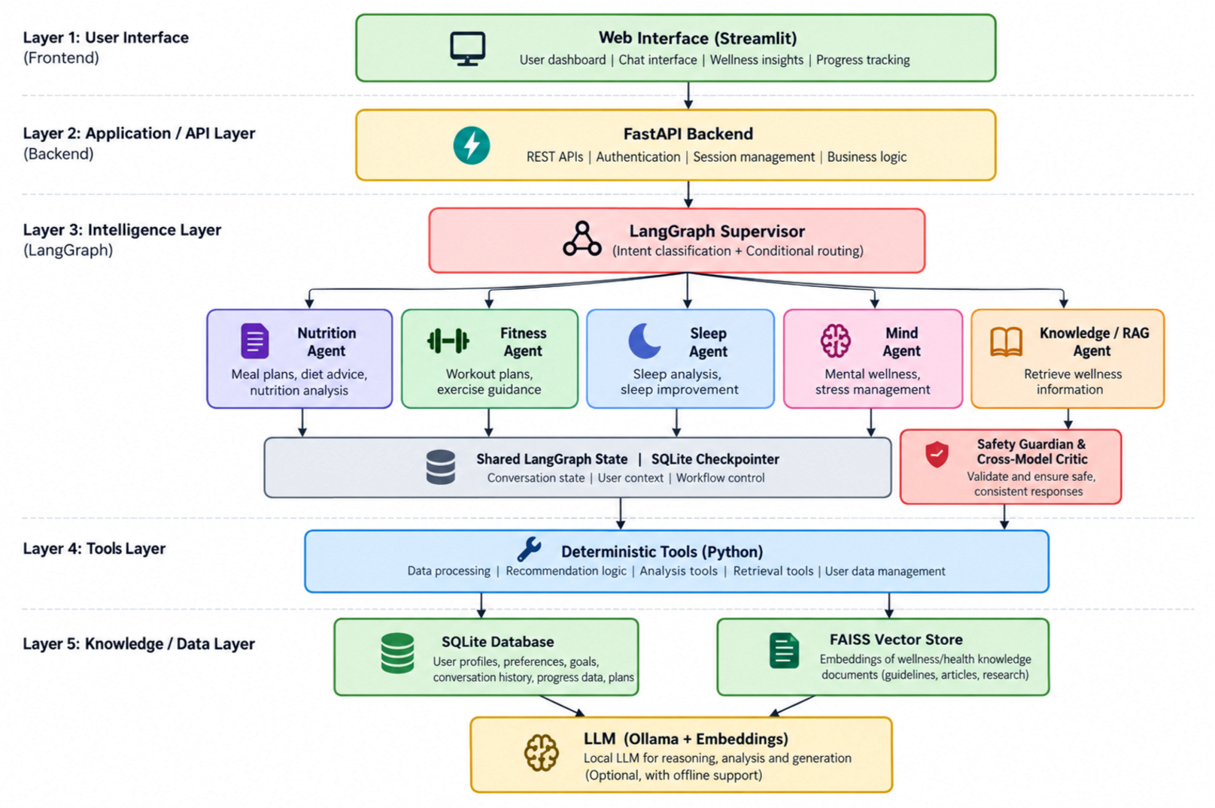
Figure 1: Layered agent architecture of the Agentic AI Employee Onboarding System

7.2 Agents
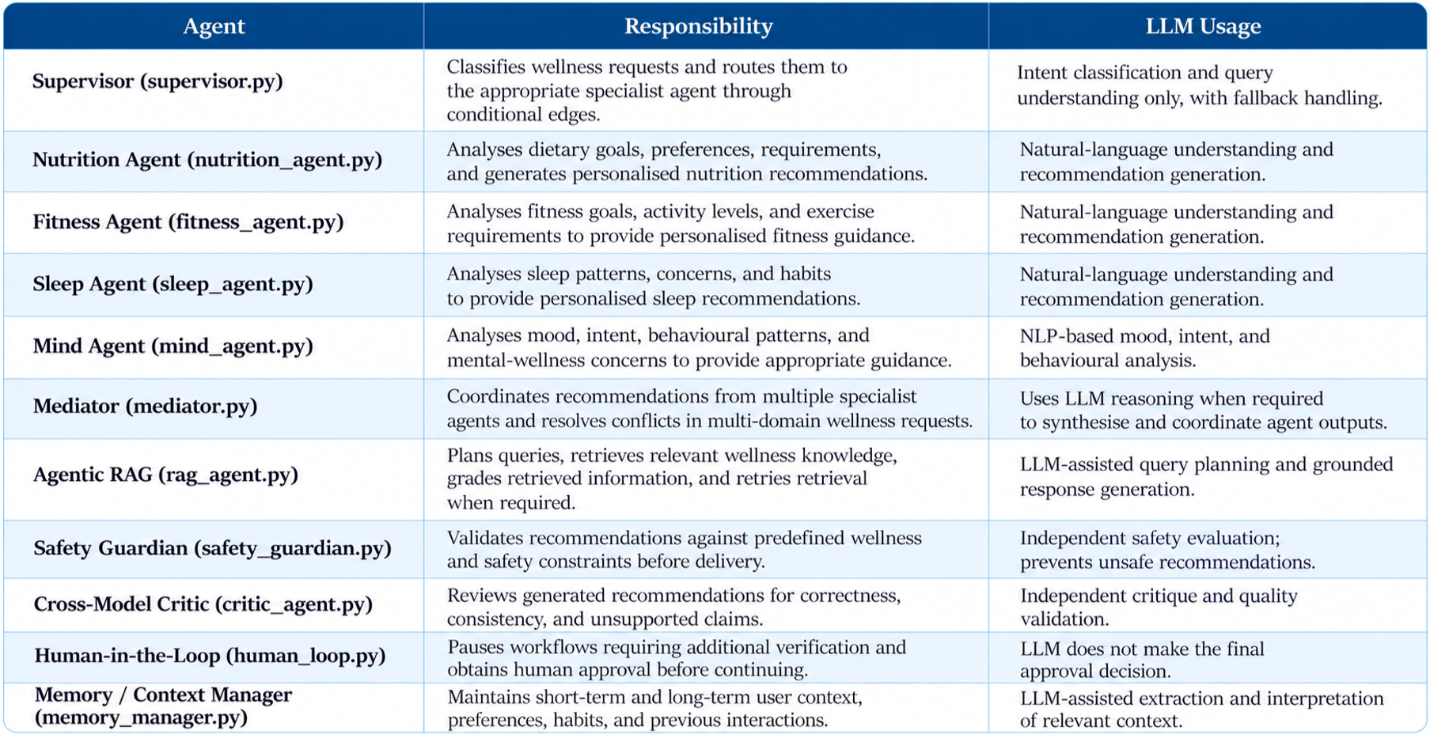

7.3 Tools
Agents interact with the system through specialised tools rather than merely generating responses. The tools associated with the agents include:
- User Context and Profile Tools for managing user goals, preferences and wellness information.
- Nutrition Tools for dietary analysis, meal planning and nutrition recommendations.
- Fitness Tools for exercise planning, activity analysis and fitness recommendations.
- Sleep Tools for analysing sleep patterns and generating sleep-related guidance.
- Mind and NLP Tools for mood, intent and behavioural analysis.
- RAG Retrieval Tools for FAISS-based semantic retrieval and knowledge-grounded responses.
- Memory Tools for storing and retrieving relevant short-term and long-term user context.
- Recommendation and Analysis Tools for processing wellness data and generating personalised insights.
- Safety and Critic Tools for validating recommendations and identifying potentially unsafe outputs.
- Agent Logger for recording important agent actions and workflow events.
- Ollama / LLM Integration for local language-model reasoning, analysis and response generation.

7.4 Memory
The system maintains user context and knowledge at several levels:
- Shared LangGraph State – maintains information exchanged between agents during a workflow.
- Short-Term Memory – retains relevant information from the current conversation and ongoing interaction.
- Long-Term Memory – stores important user preferences, goals, habits and previous interactions for future personalisation.
- SQLite Database – stores user profiles, wellness information, recommendations and progress data.
- FAISS Index – maintains long-term wellness knowledge used by the RAG component.
- Agent Activity Logs – maintain a record of important agent actions and workflow execution.
This allows HealthPilot to maintain context across interactions, provide personalised recommendations and adapt its responses based on the user's previous information and behaviour..

7.5 Design Rules
The architecture follows these design rules:
- Agents use specialised tools for data processing, retrieval and wellness analysis rather than only generating unsupported responses.
- Safety-critical decisions are validated through deterministic checks and independent safety components.
- Knowledge is retrieved through RAG rather than relying entirely on the LLM's internal knowledge.

4. Agents communicate through shared LangGraph state to maintain consistent workflow context.
- Each agent has a focused responsibility such as nutrition, fitness, sleep or mental wellness.
- Important agent actions are logged to maintain transparency and traceability.
- The system degrades gracefully when the LLM or retrieval services are unavailable.
- User context and memory are maintained to provide personalised and continuously adaptive recommendations.
- Human-in-the-loop validation is used when recommendations require additional verification.

8. AGENT WORKFLOW AND ORCHESTRATION

8.1 Workflow Design
Every user request enters the HealthPilot system through the application interface and is passed to the LangGraph Supervisor, which analyses the request and routes it to the appropriate specialised workflow. Depending on the request, the Supervisor can route it to the Nutrition, Fitness, Sleep, Mind or RAG agents. Multi-domain requests can involve multiple agents through the Mediator.

8.2 General Wellness Query Workflow
User Query
↓
Supervisor
↓
Specialist Agent
(Nutrition / Fitness / Sleep / Mind)
↓
Agentic RAG (when required)
↓
Mediator
↓
Safety Guardian + Cross-Model Critic
↓
Human Approval (when required)
↓
Final Recommendation
↓
Memory / Logging

Step 1 — Input Collection. The user submits a wellness-related query through the application.
Step 2 — Routing. The Supervisor analyses the request and identifies the appropriate specialist agent.
Step 3 — Specialist Analysis. The selected agent analyses the user's requirements, goals, preferences and available context.
Step 4 — Knowledge Retrieval. When additional information is required, the Agentic RAG component retrieves relevant knowledge and evaluates the retrieved information.
Step 5 — Coordination. For multi-domain requests, the Mediator combines the outputs of different specialist agents and resolves conflicting recommendations.
Step 6 — Safety Validation. The Safety Guardian and Cross-Model Critic evaluate the generated recommendation for safety, consistency and quality.
Step 7 — Human Approval. Recommendations requiring additional verification can be sent for human review before being finalised.
Step 8 — Finalisation. The validated recommendation is presented to the user and relevant context can be stored in memory.

8.3 Personalised Recommendation Workflow
User Context
↓
Supervisor
↓
Specialist Agent
↓
Memory + User Preferences
↓
Recommendation Generation
↓
Safety / Critic Validation
↓
Final Personalised Recommendation

Step 1 — Context Retrieval. Relevant user preferences, goals, previous interactions and behavioural information are retrieved.
Step 2 — Analysis. The appropriate specialist agent analyses the user's current requirements together with the stored context.
Step 3 — Recommendation. A personalised recommendation is generated according to the relevant wellness domain.
Step 4 — Validation. The recommendation is evaluated by the safety and critic components.
Step 5 — Adaptation. The recommendation and user response can contribute to future personalisation through the memory system.

8.4 Agentic RAG Workflow
User Query
↓
Query Planning
↓
Knowledge Retrieval
↓
Retrieval Grading
↓
Sufficient Information?
↙ ↘
Yes No
↓ ↓
Generate Retry Retrieval
Answer ↓
↓ Generate /
Safety Check Safe Response

The Agentic RAG workflow plans the retrieval operation, searches the FAISS knowledge base, evaluates the retrieved information and retries when the available context is insufficient. This helps reduce unsupported responses and provides grounded information to the specialist agents.

8.5 State, Persistence and Fallback
- All agents communicate through a shared LangGraph state, allowing relevant information to move between specialised components.
- Short-term and long-term memory preserve relevant user context for personalised interactions.
- Agent activity and workflow information can be stored for monitoring and evaluation.
- If the LLM or retrieval service is unavailable, the system uses available fallback mechanisms to maintain basic functionality.
- The modular architecture allows AI models, knowledge sources and specialist agents to be replaced or extended without redesigning the complete system.

9. AGENTIC RAG IMPLEMENTATION
The system implements Retrieval-Augmented Generation (RAG) to provide reliable, knowledge-grounded wellness responses. The RAG component retrieves relevant information from the wellness knowledge base and supplies it as context to the specialised agents. Since retrieval is integrated into the multi-agent workflow and can be invoked dynamically based on the user's request, the system implements an agentic RAG approach rather than a standalone question-answering system.

9.1 Retrieval Architecture
Wellness Knowledge Documents
|
↓
Preprocessing / Chunking
|
↓
Embedding Generation
|
↓
FAISS Vector Store
|
↓
Agentic Retriever
(Semantic Retrieval + Fallback Retrieval)
|
↓
Relevant Knowledge Chunks
|
↓
Specialist / RAG Agent
|
↓
LLM with Retrieved Context
|
↓
Grounded Response

The FAISS vector index is initialized during application start-up to make the knowledge base ready for retrieval. If embedding generation or the vector retrieval service is unavailable, the system automatically falls back to keyword-based search over the same knowledge documents, ensuring that the RAG workflow remains functional.

9.2 Knowledge Retrieval
When a user asks a wellness-related question, such as “What foods are suitable for my fitness goal?”, the retrieval system identifies relevant:
- Wellness and health-related information
- Nutrition, fitness, sleep or mental-wellness guidance
- Knowledge documents and relevant sections containing the required information
The retrieved chunks are supplied to the appropriate specialist agent and language model as contextual information. The response is then generated using the retrieved knowledge along with the user's relevant context and preferences. When a specialist agent requires external knowledge during its workflow, it invokes the Agentic RAG component in the same way and uses the retrieved context during its recommendation process.

9.3 Generation Process The LLM receives:
User Query + Retrieved Knowledge Chunks + Relevant User Context

The retrieved knowledge provides supporting information, while the user's goals, preferences and previous context are used to personalise the response. The LLM generates the final response based on the available retrieved information rather than relying solely on its internal knowledge.

9.4 Retrieval Quality Evaluation
Possible evaluation measures include:

● Retrieval relevance

● Context precision

● Context recall

● Answer groundedness

● Response relevance
- Correct response rate for questions requiring information from the knowledge base
- Retrieval success rate for domain-specific wellness queries

● Hallucination / unsupported response rate
These measures are evaluated using a test set of wellness-related questions covering nutrition, fitness, sleep and mental-wellness knowledge. The measured results are reported in Section

10. SYSTEM IMPLEMENTATION

10.1 Frontend
The frontend is a Streamlit-based interactive application that provides a unified interface for interacting with the HealthPilot wellness system. It provides interfaces for:
- User interaction and wellness queries
- Personalised Nutrition, Fitness, Sleep and Mind recommendations
- User profile, goals and preferences
- Wellness progress and recommendation history
- Agentic RAG-based knowledge interaction
- Memory-aware personalised conversations
- Safety and recommendation feedback
Supporting modules include the Streamlit application interface, session-state management, user-context handling, agent workflow integration and components for displaying recommendations and wellness information. The interface communicates with the LangGraph-based backend to route requests through the appropriate specialised agents.

10.2 Backend
The backend is implemented in Python and is responsible for:
- Receiving and processing user wellness requests
- Managing user context, preferences and wellness information ● Invoking LangGraph multi-agent workflows
- Routing requests through the Supervisor and specialist agents
- Performing knowledge retrieval through the Agentic RAG pipeline
- Managing short-term and long-term memory
- Coordinating recommendations through the Mediator
- Validating responses through the Safety Guardian and Cross-Model Critic
- Communicating with the database and FAISS vector store
- Calling the local LLM through Ollama
- Returning personalised responses to the frontend
At start-up, the application initialises required data resources, loads the knowledge base and prepares the FAISS index for retrieval. The major functional components are summarised below.
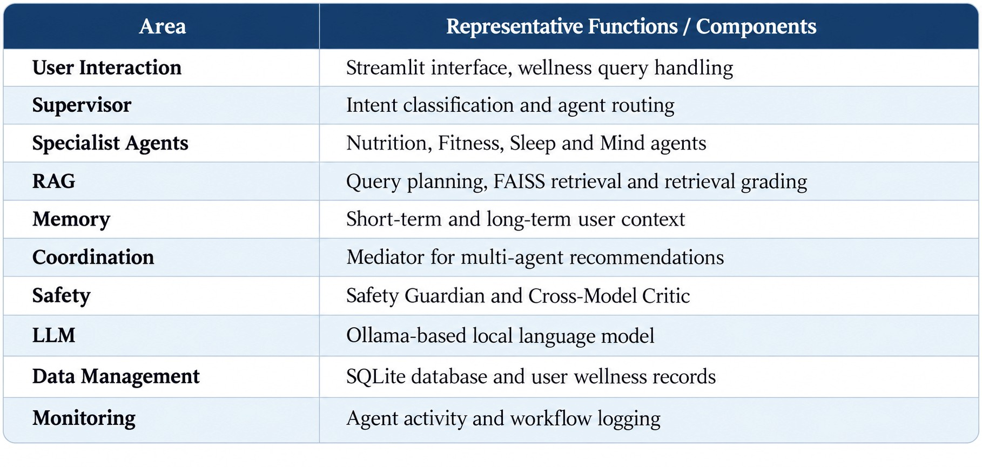

10.3 Database and Security
The database layer uses SQLAlchemy with SQLite to store user profiles, wellness information, preferences, goals, interactions and progress data. The database is initialised during application start-up, while CRUD operations provide structured access to the stored user and wellness information.
Authentication and Data Protection
The system manages user sessions and restricts access to personalised wellness information. User context is handled within the application workflow so that recommendations and stored information remain associated with the appropriate user.
Roles
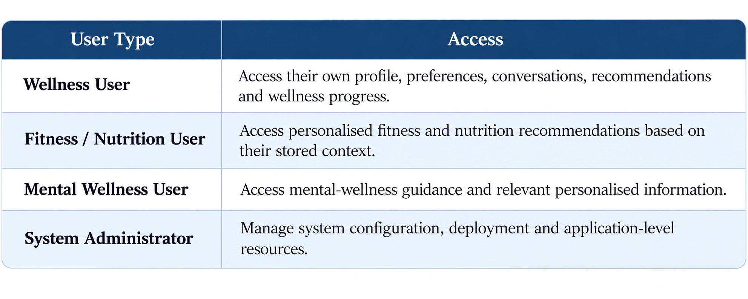

Data Scope Enforcement
User-specific information is maintained within the appropriate application context. Agents retrieve only the information required for the current workflow, while shared LangGraph state is used to pass relevant information between agents. This prevents unnecessary duplication of user information and supports personalised, context-aware recommendations.
Safety and AI Validation
Generated recommendations are additionally evaluated by the Safety Guardian and Cross-Model Critic before delivery. This provides an additional protection layer for potentially unsafe or inconsistent AI-generated wellness guidance.

10.4 AI Integration
Ollama is integrated into the system to provide local LLM capabilities for:
- Intent classification and request routing through the Supervisor
- Natural-language understanding and user query analysis
- Personalised recommendation generation
- Mood, intent and behavioural analysis
- Grounded response generation using retrieved knowledge
- Reasoning and coordination across specialised agents
The LLM is primarily used for language understanding, reasoning and generation, while retrieval, user-data management, workflow control and safety validation are handled through dedicated components. The system can operate with locally hosted models, reducing dependence on external API keys and allowing the underlying model to be replaced or extended as required.

10.5 Prototype Screenshots
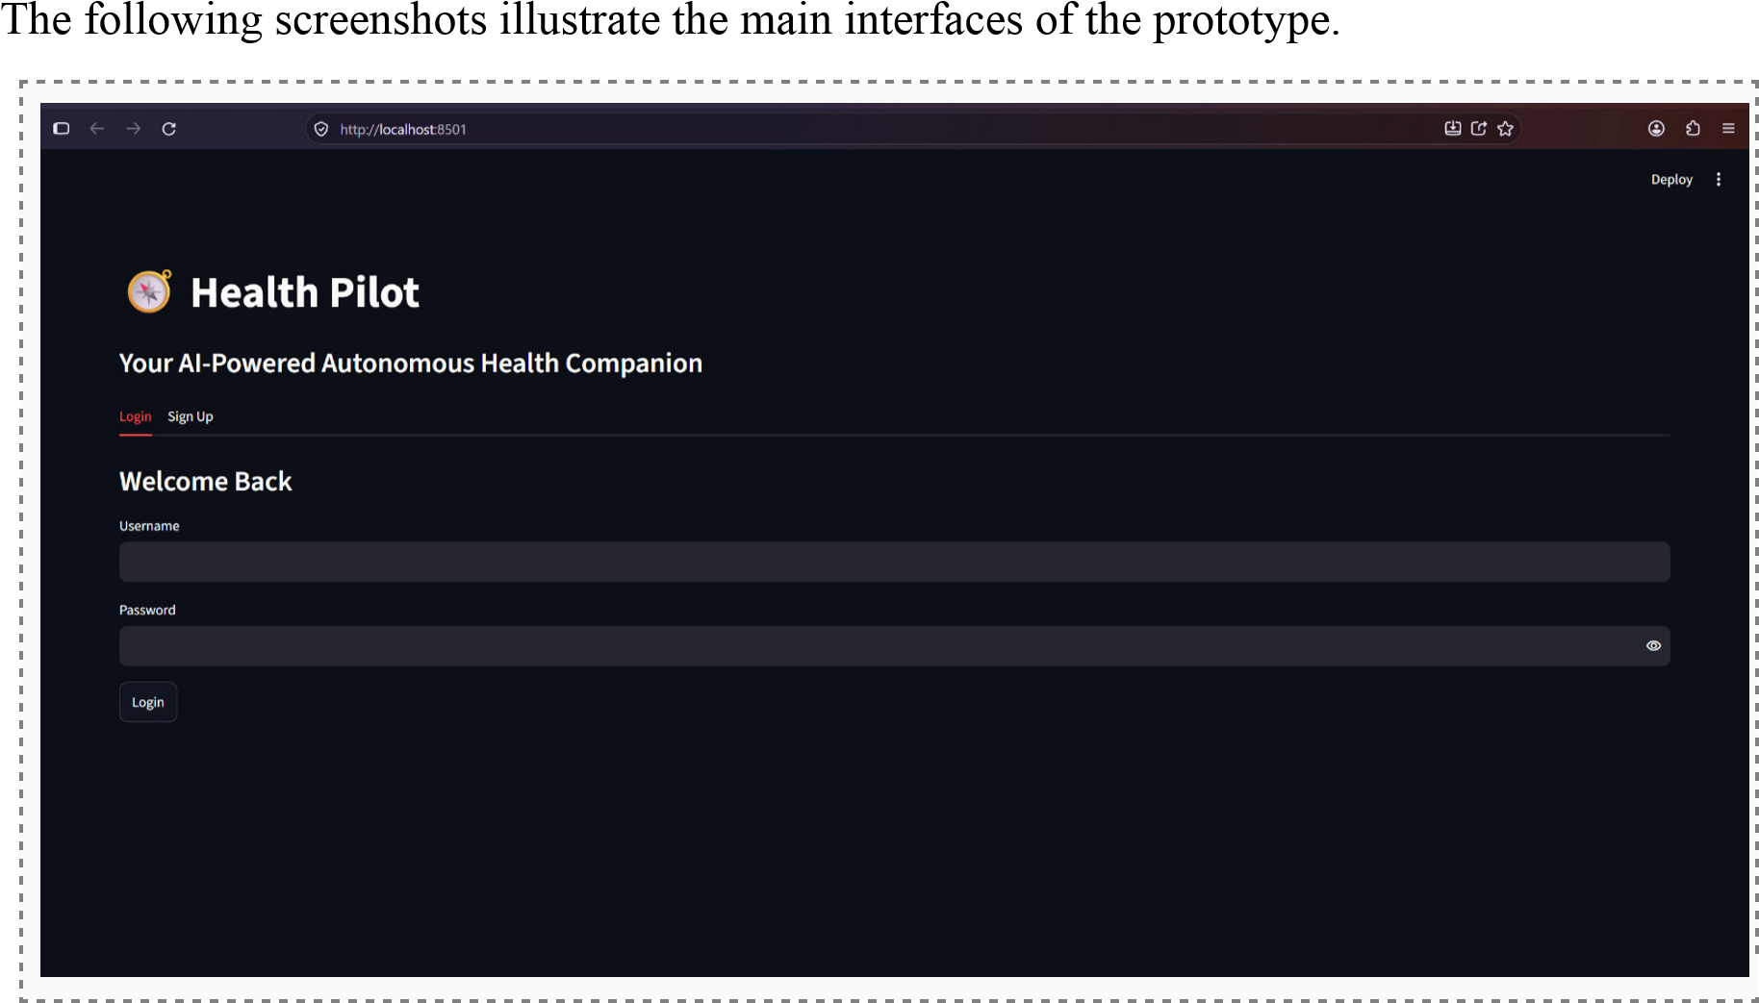
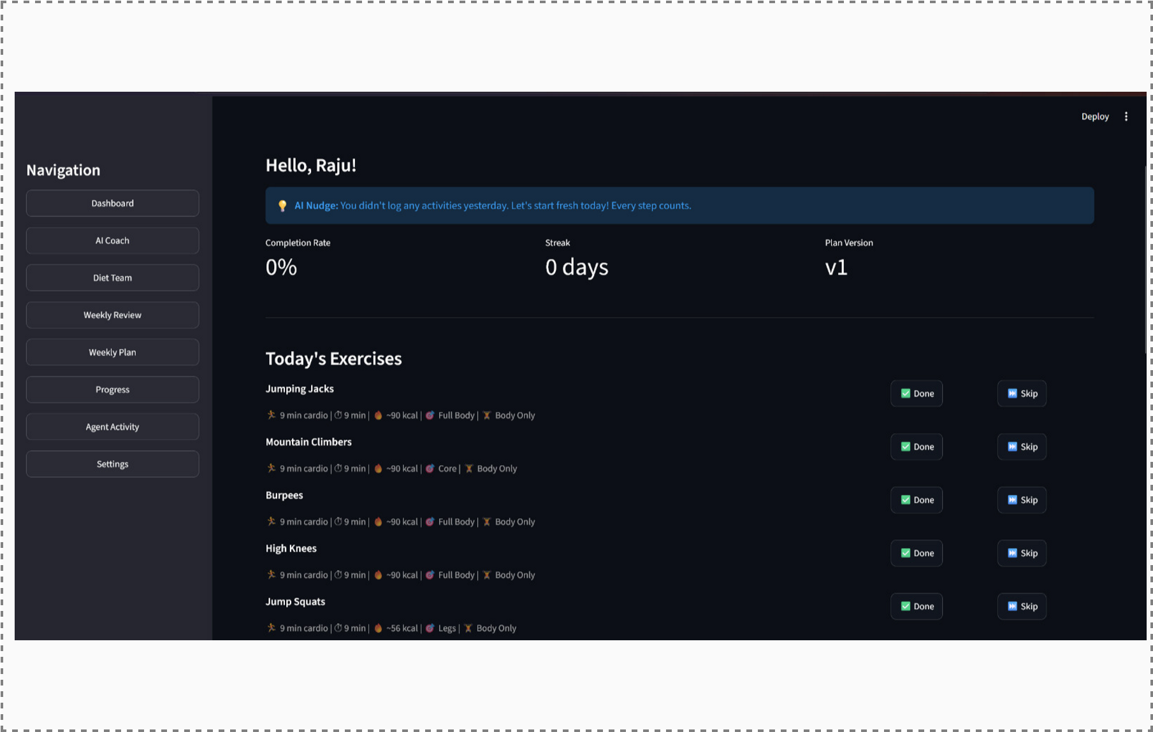
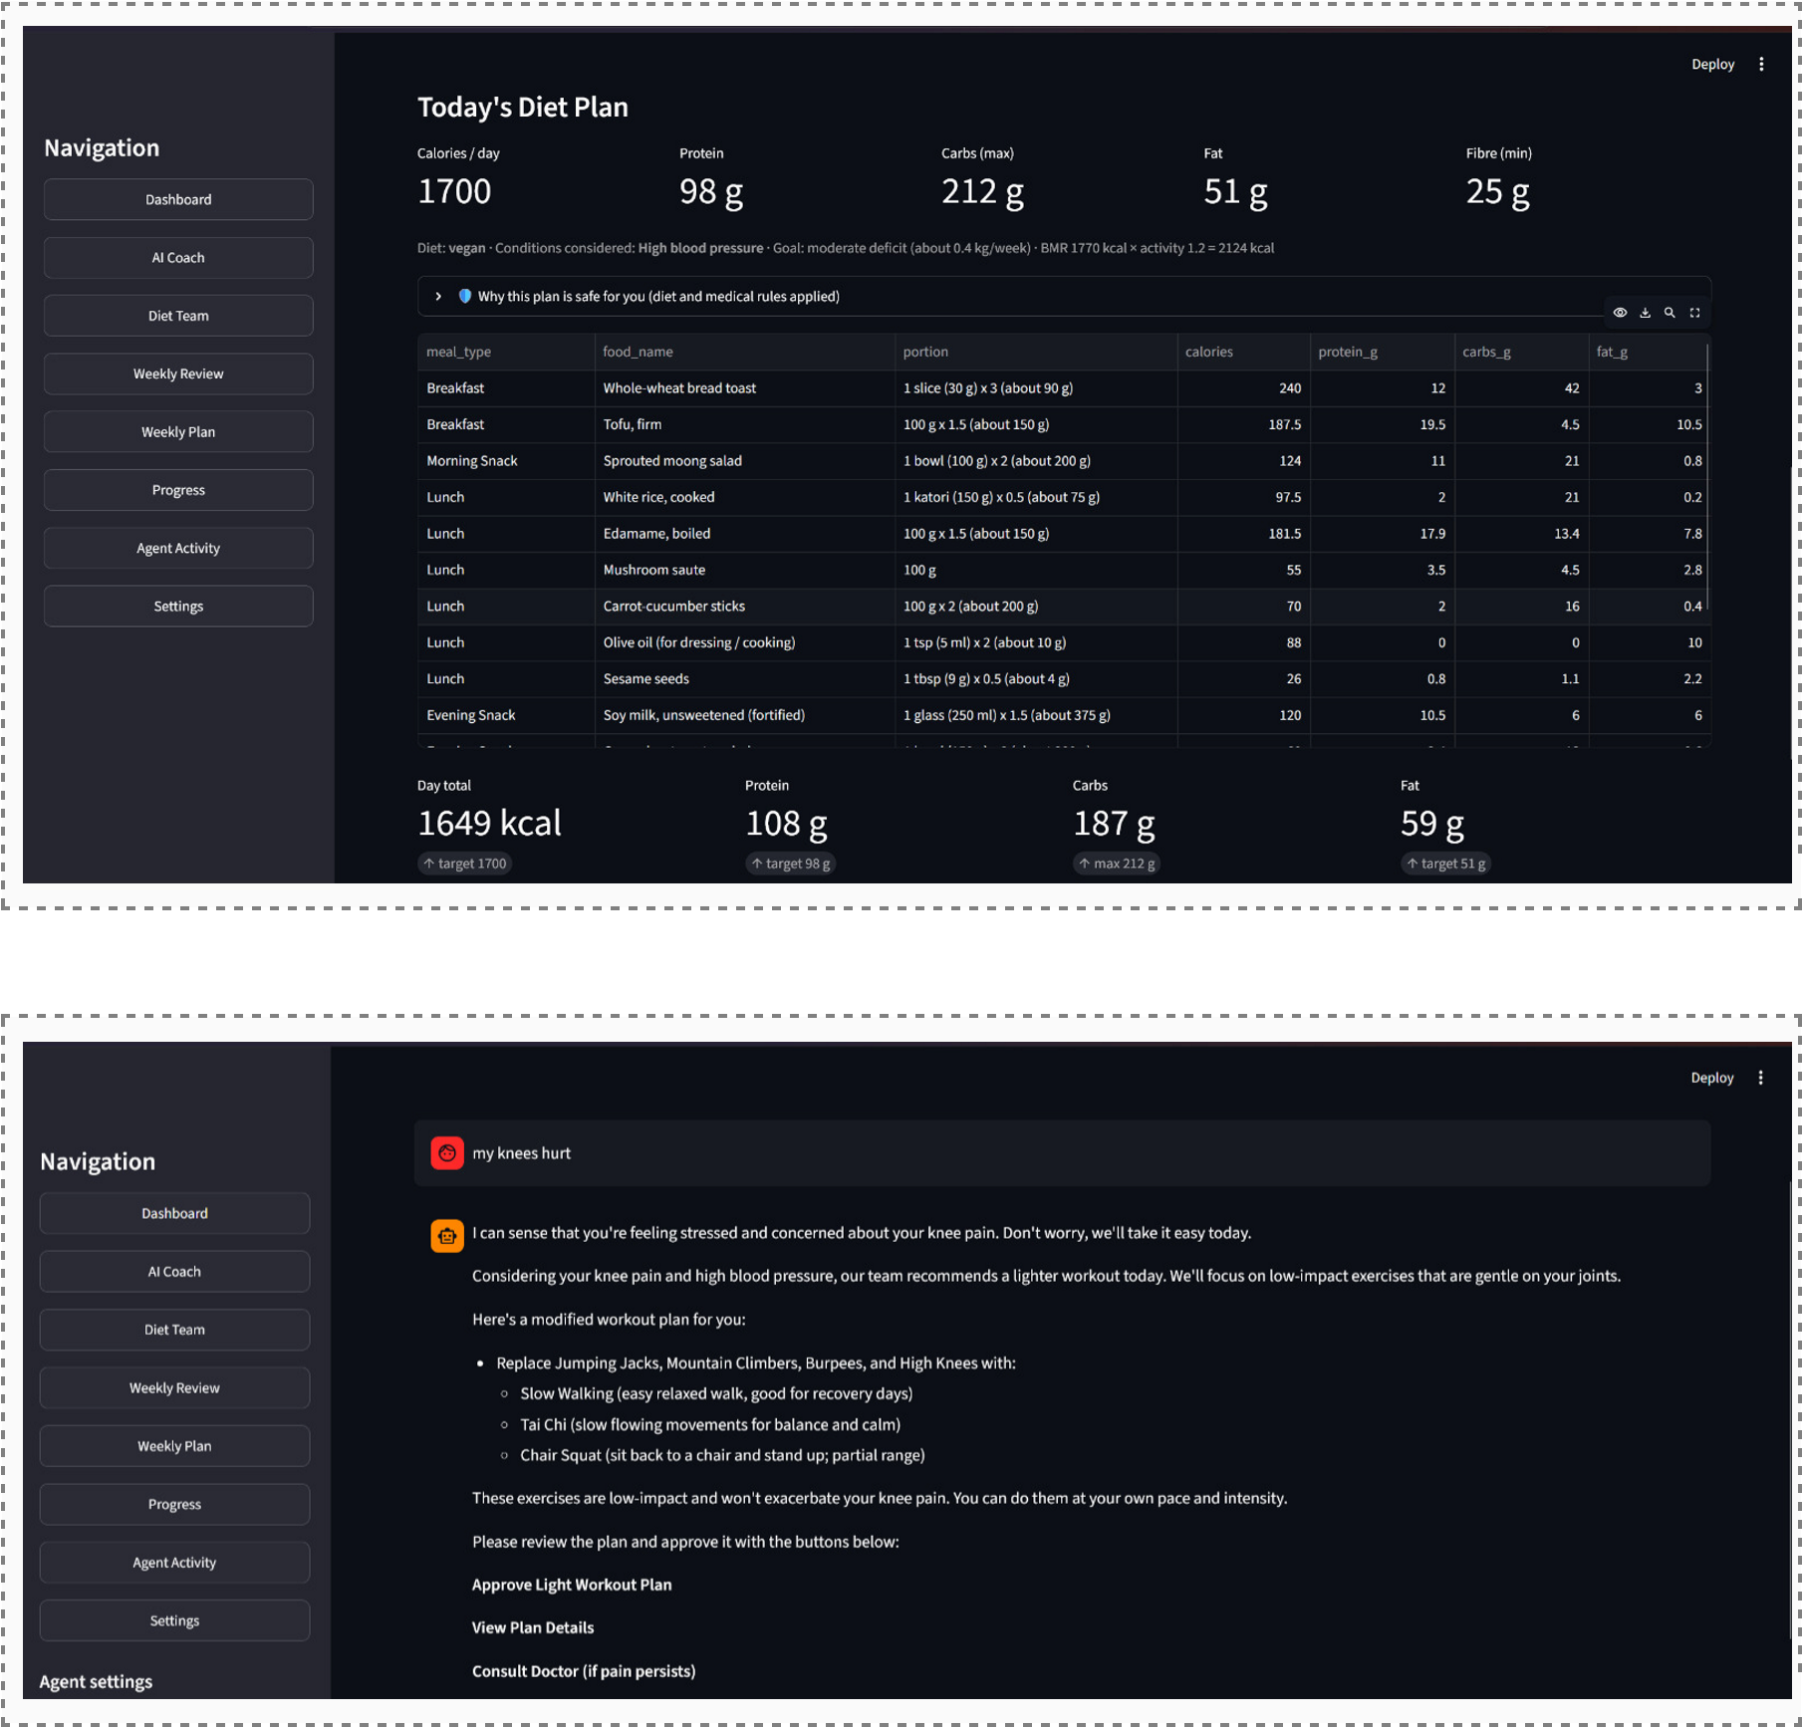
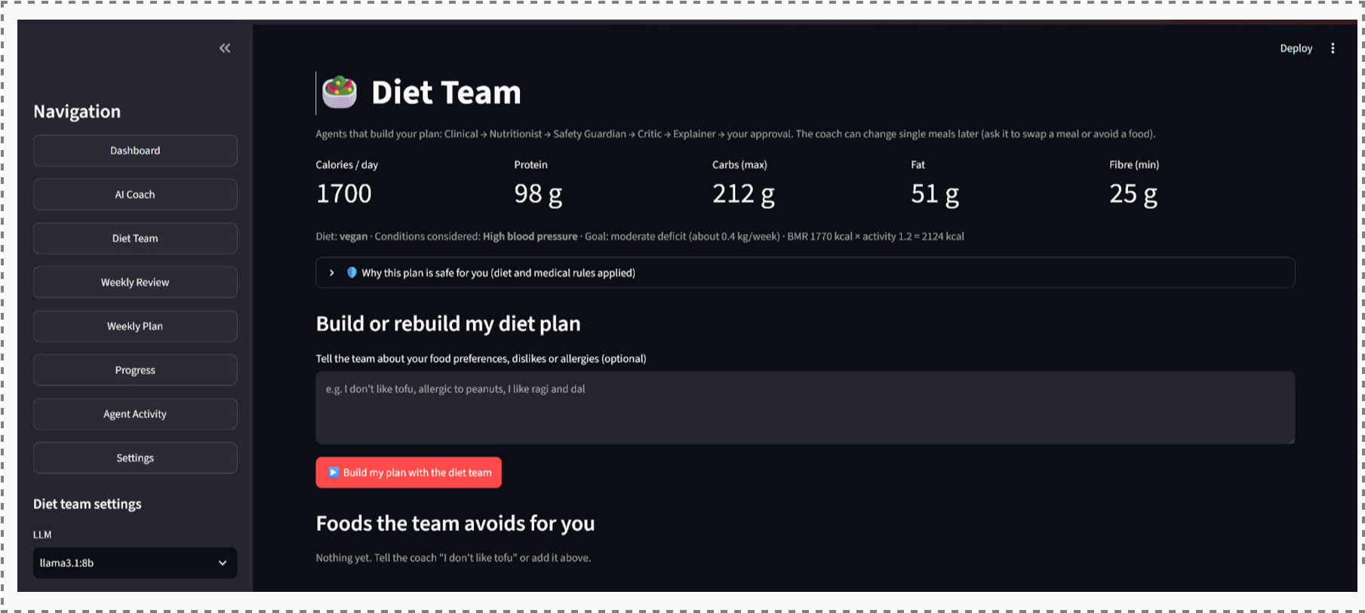

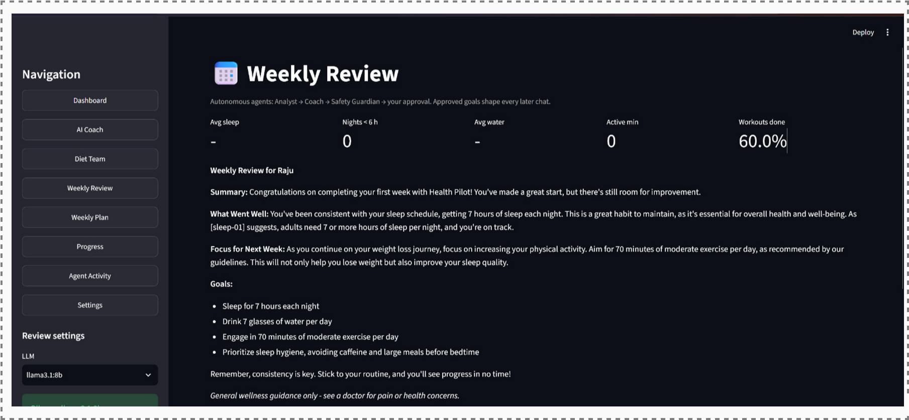
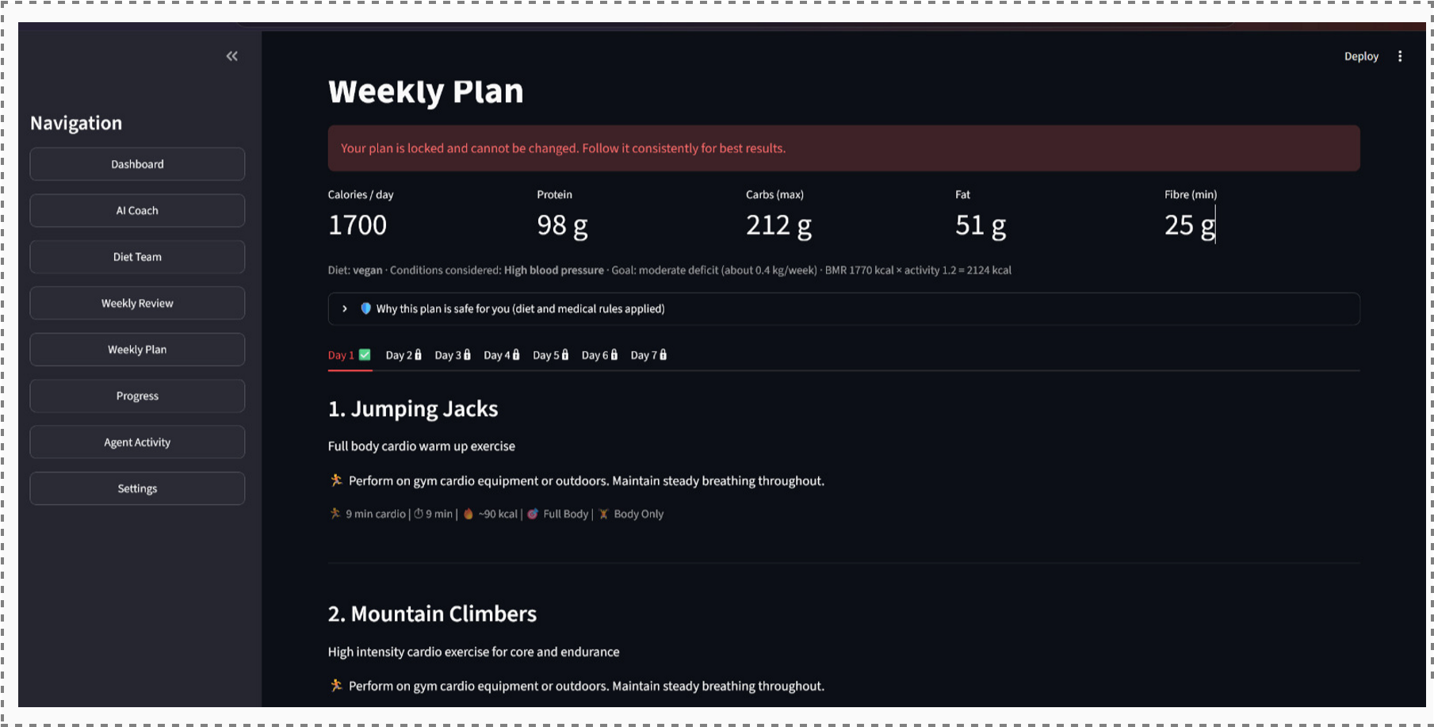

11. EXPERIMENTAL EVALUATION AND RESULTS

11.1 Evaluation Strategy
The system is evaluated to determine whether the multi-agent workflows operate correctly, recommendations remain relevant and grounded, safety mechanisms function as intended, and the system responds reliably. Important evaluation dimensions include:
- Workflow completion
- Recommendation quality and correctness
- RAG retrieval relevance and groundedness
- Safety and validation performance
- Personalisation and contextual relevance
- Response time
- Robustness and graceful degradation
- Memory and adaptation effectiveness

11.2 Workflow Completion
For each wellness workflow run:

Workflow Completion Rate = (Successful Runs / Total Runs) × 100
For a wellness workflow, a successful run must correctly route the user request to the appropriate specialist agent, generate a relevant recommendation, complete any required RAG retrieval and validation steps, and record the corresponding workflow activity. For multi-agent requests, successful completion also requires proper coordination through the Mediator and successful Safety Guardian validation. The functional test cases used are listed below; the Result column is completed from testing.
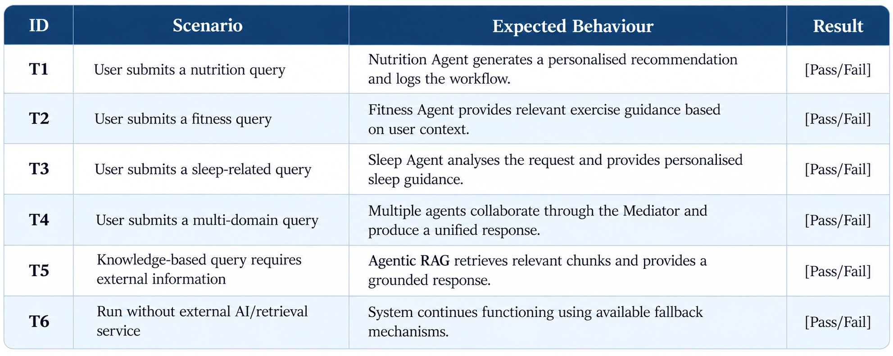

11.3 Decision Accuracy
Wellness recommendations can be compared against the expected outcome computed independently from predefined safety and wellness rules:
Wellness / Safety Rules + User Context
|
v
Expected Decision
(Approve / Reject / Needs Approval)
|
v
System Decision
|
Compare
/ \
Match Mismatch

Recommendation Accuracy = (Matching Recommendations / Total Test Requests) × 100
Because safety constraints, user preferences, wellness goals, and recommendation validation rules are handled through deterministic components, the expected outcome can be computed independently of the LLM. The system-generated recommendation is then compared with this expected outcome. The LLM primarily influences natural-language understanding, query interpretation, and recommendation generation.
The same comparison can be applied to agent routing (correct specialist agent selected), safety validation (correct approval/rejection/escalation), and wellness plan generation (appropriate recommendations for the user’s goals and context).

11.4 Safety, Validation and Access-Control Testing
Security and safety controls are verified using negative and boundary-condition tests to ensure that unsafe, invalid, or unauthorised wellness requests are not processed without appropriate validation:
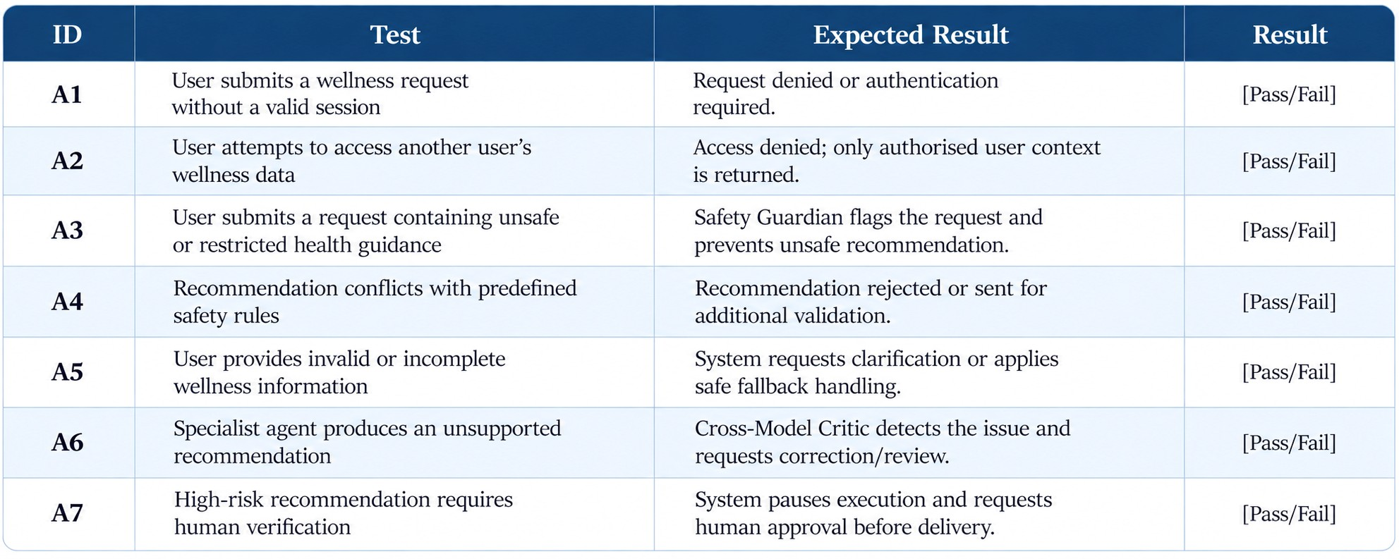

11.5 AI Response Evaluation
The HealthPilot specialist agents, Agentic RAG pipeline, and LLM-generated recommendations can be evaluated using:
- Relevance – does the recommendation directly address the user’s wellness query and goals?
- Completeness – does it consider the applicable user preferences, context, constraints, and wellness requirements?
- Groundedness – are knowledge-based recommendations supported by the retrieved information from the knowledge base?
- Correct Safety Handling – does the system appropriately reject, modify, or escalate recommendations that violate predefined safety rules?
- Personalisation Quality – does the recommendation appropriately reflect the user’s stored goals, preferences, habits, and previous interactions?
- Agent Routing Accuracy – is the query correctly routed to the appropriate Nutrition, Fitness, Sleep, or Mind agent?
- Response Consistency – does the system provide reasonably consistent recommendations across repeated queries with the same context?
- RAG Retrieval Quality – are the retrieved knowledge chunks relevant and sufficient for generating the final recommendation?
- Adaptation Quality – does the system appropriately update future recommendations based on changes in user behaviour, preferences, and wellness progress?
•

11.6 Performance Evaluation
System-level measurements can include:
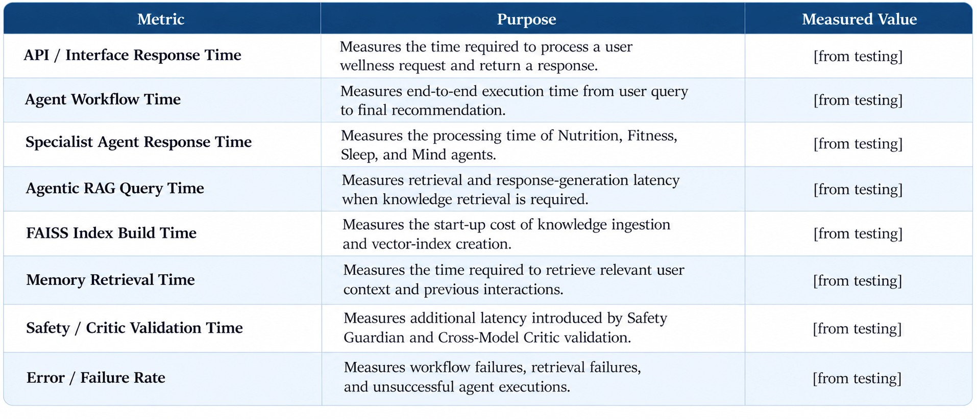

Actual numerical values are to be inserted from testing on the deployed prototype.

12. COMPARISON, INNOVATION AND SCALABILITY

12.1 Conventional Wellness Applications vs the Proposed HealthPilot System
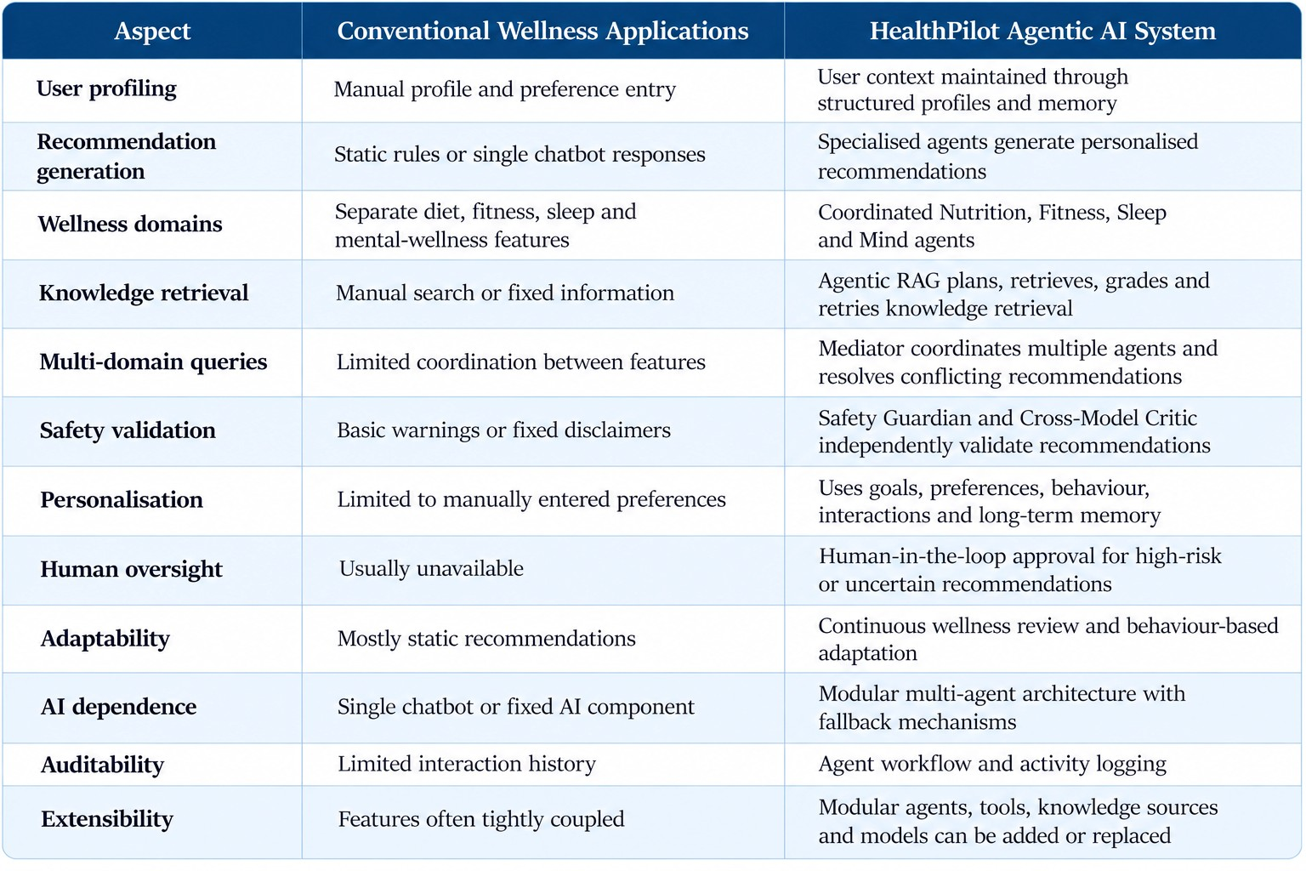
This comparison describes system characteristics rather than assigning an overall ranking.

12.2 Innovation
The project combines several advanced requirements that are often implemented as separate components:

Multi-Agent Orchestration + Agentic RAG + Safety Validation + Human-in-the-Loop + Memory + Continuous Adaptation
The central innovation of HealthPilot is the disciplined use of AI for personalised wellness management. Specialised agents coordinate through a shared LangGraph state, while the Supervisor routes requests to the appropriate Nutrition, Fitness, Sleep, or Mind agent. Agentic RAG provides grounded knowledge through planning, retrieval, grading, and retry mechanisms. Safety-critical recommendations are independently checked by the Safety Guardian and Cross-Model Critic, with high-risk cases capable of being paused for human approval. User memory and behavioural analysis allow recommendations to adapt over time, while fallback mechanisms allow the system to continue operating when individual AI or retrieval components are unavailable.

12.3 Scalability
The HealthPilot system can be extended from a prototype into a broader AI-powered wellness platform.
Database Scalability
The SQLAlchemy-based data layer allows the application to migrate from SQLite to a more scalable relational database such as PostgreSQL when the number of users and stored wellness records increases.
AI Scalability
New specialist agents can be added as independent LangGraph nodes without redesigning the complete workflow. The LLM layer is modular, allowing different local or cloud-based models to be integrated according to performance and deployment requirements.
Knowledge Scalability
Additional wellness, nutrition, fitness, sleep, and mental-wellness documents can be added to the knowledge base and re-ingested into the FAISS vector index. This allows the Agentic RAG system to expand its knowledge without modifying the core agent architecture.
Application Scalability
The modular and containerised architecture can be extended with:
- Wearable and health-tracking integrations
- External nutrition and fitness APIs
- Advanced user analytics and wellness dashboards
- Cloud-based vector databases for larger knowledge collections
- LangSmith or similar observability tools for agent tracing
- Additional safety and validation models
- Voice-based wellness interaction
- Multi-user and organisation-level wellness management
- Additional LLM providers or models
- Automated notification and wellness-review service

12.4 Real-World Applicability
HealthPilot can be applied in several real-world health and wellness scenarios, including:
- Individual health and wellness coaching
- Fitness centres and personal training platforms
- Nutrition and diet-planning applications
- Corporate wellness programmes
- Educational institutions and student wellness support
- Digital health and wellness technology providers
- Wellness applications integrated with wearable devices
A future version could connect with real-world health and fitness data sources, wearable devices, nutrition databases, and communication platforms, allowing the system to continuously analyse user behaviour and provide personalised recommendations. The workflow could progress from an initial wellness profile and user goals to continuous monitoring, periodic wellness reviews, adaptive recommendations, and human escalation when required, with minimal manual intervention.

13. CONCLUSION AND FUTURE WORK

13.1 Conclusion
The HealthPilot – Agentic AI Health & Wellness Coach demonstrates how multiple specialised AI agents can be coordinated to provide personalised wellness support while maintaining safety, reliability, and user control. LangGraph orchestrates the Supervisor and specialised Nutrition, Fitness, Sleep, and Mind agents through a shared state, with a Mediator coordinating multi-domain recommendations and resolving conflicts between agents.
Unlike a standalone chatbot, HealthPilot uses AI as part of a structured workflow rather than relying on a single model to make every decision. The LLM is primarily used for tasks such as natural-language understanding, intent classification, mood and behavioural analysis, recommendation generation, and reasoning. Knowledge-intensive responses are supported by Agentic RAG, which performs query planning, retrieval, relevance grading, and retry when required. User information and previous interactions are maintained through short-term and long-term memory to improve personalisation over time.
Safety and reliability are treated as separate concerns from language generation. The Safety Guardian validates recommendations against predefined safety requirements, while the Cross-Model Critic provides an additional layer of independent validation. When a recommendation requires additional verification, the Human-in-the-Loop mechanism can pause the workflow for approval before the response is delivered. The system also includes fallback mechanisms so that individual AI or retrieval components do not necessarily cause complete workflow failure.
The full-stack implementation using Python, LangGraph, LangChain, Ollama, FAISS, SQLite, SQLAlchemy, Pydantic, and Streamlit, together with memory, RAG, agent coordination, safety validation, and workflow logging, demonstrates that agentic AI can be integrated into a practical wellness application. The objective is not merely to generate conversational responses, but to provide context-aware, personalised, grounded, safety-validated, and continuously adaptive wellness guidance.

13.2 Future Work
- Wearable and Health-Data Integration – integrate fitness trackers and wearable devices to incorporate activity, sleep, heart-rate, and other user-authorised wellness data.
- Advanced Personalisation – develop stronger user modelling that learns long-term preferences, habits, goals, and behavioural patterns to improve recommendation quality.
- Continuous Wellness Monitoring – introduce automated periodic reviews that analyse changes in user behaviour and generate updated wellness plans.
- Voice-Based Interaction – add speech recognition and voice responses to support hands-free interaction with the wellness coach.
- Advanced RAG and Knowledge Sources – expand the knowledge base with additional verified nutrition, fitness, sleep, and wellness resources and explore scalable vector databases beyond FAISS.
- Production Database and Deployment – migrate from SQLite to PostgreSQL and deploy the system using scalable cloud infrastructure for larger numbers of users.
- Enhanced Safety and Human Oversight – introduce stronger safety policies, specialised validation models, confidence-based escalation, and improved human approval workflows for high-risk situations.
- Observability and Evaluation – integrate agent-tracing and monitoring tools to analyse workflow performance, retrieval quality, agent decisions, response latency, and safety outcomes.
- Multi-User and Organisational Wellness – extend HealthPilot to support gyms, educational institutions, corporate wellness programmes, and professional wellness providers while maintaining strict user-data isolation.
- Model Flexibility and Optimisation – support multiple LLM providers and models, enabling the system to select models based on task complexity, latency, privacy requirements, and computational resources.

